**Project Design Phase-II**

**Technical Architecture**

|  |  |
| --- | --- |
| **NAME** | **M.DINESH** |
| **NM ID** | **8E2B4970F2F803A9B084E092E573C2AC** |
| **PROJECT NAME** | **Creating a sponsored post for Instagram** |

**Technical Architecture for creating a sponsored post for instagram**

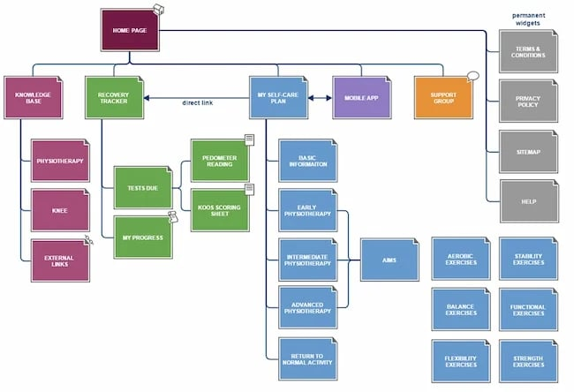

Creating a technical architecture for a project like "Creating a Sponsored Post for Instagram" involves designing a scalable, secure, and efficient system to handle user authentication, content creation, scheduling, analytics, and other essential functions. Below is a high-level technical architecture for this project:

**1. Front-end Application:**

**React.js:** Use React for building the user interface. React is a popular and efficient library for creating dynamic and interactive web applications.

2**. Back-end Server:**

**Node.js with Express.js**: Node.js provides a non-blocking, event-driven architecture that is ideal for handling a high volume of requests. Express.js is a minimal and flexible Node.js web application framework that simplifies API development.

**3. Database:**

**Relational Database Management System (RDBMS):** Choose an RDBMS like PostgreSQL or MySQL to store user data, post content, and analytics data. This is important for maintaining data consistency and reliability.

**4. Instagram API Integration:**

Integrate with the Instagram Graph API for features like user authentication, post scheduling, and post analytics. This allows your application to interact with Instagram's platform.

**5. Content Delivery:**

Use a content delivery network (CDN) to serve images and media content efficiently to users. A CDN helps reduce load times and ensures a seamless user experience.

6**. Security Layer:**

Implement security measures to protect user data and application integrity. This includes user authentication, data encryption, and secure communication with the Instagram API.

**7. Load Balancer:**

Employ a load balancer to evenly distribute incoming traffic across multiple server instances. This ensures high availability and reliability of the application.

**8. Caching Layer:**

Use caching mechanisms (e.g., Redis) to store frequently accessed data, such as user profiles and frequently used hashtags. Caching helps reduce database load and improves response times.

**9. Payment Gateway Integration (Optional):**

If the application supports payment processing for sponsored posts, integrate with a payment gateway provider to handle transactions securely.

**10. Application Logic:**

Develop the core application logic, including user account management, content creation, scheduling, and analytics tracking. Ensure that business rules and algorithms are efficiently implemented.

**11. API Layer:**

Design RESTful API endpoints for client-server communication. These endpoints should facilitate actions like creating posts, scheduling, and accessing analytics.

**12. Analytics and Reporting:**

Implement tools and libraries to collect and analyze user engagement and post performance data. Use a dedicated database or data warehouse for storing analytics data.

**13. Monitoring and Logging:**

Set up monitoring tools like Prometheus or New Relic to track system performance and detect issues in real time. Implement comprehensive logging to aid in debugging and auditing.

**14. Continuous Integration/Continuous Deployment (CI/CD):**

Utilize CI/CD pipelines for automated testing and deployment, ensuring that code changes are thoroughly tested and deployed seamlessly.

**15. Scalability and Cloud Hosting:**

Deploy the application on a cloud platform (e.g., AWS, Google Cloud, Azure) to leverage scalability features and easily handle increasing user loads. Configure auto-scaling based on traffic patterns.

**16. Data Privacy and Compliance:**

Ensure that the system complies with data privacy regulations and industry standards, such as GDPR or HIPAA, depending on the scope and nature of the project.

**17. User Training and Support:**

Provide training materials and a support system for users to navigate the platform effectively.

This technical architecture outlines the components and technologies needed to build a Sponsored Post for Instagram application. It's important to follow best practices for security, performance, and scalability while continuously monitoring and optimizing the system for an optimal user experience.